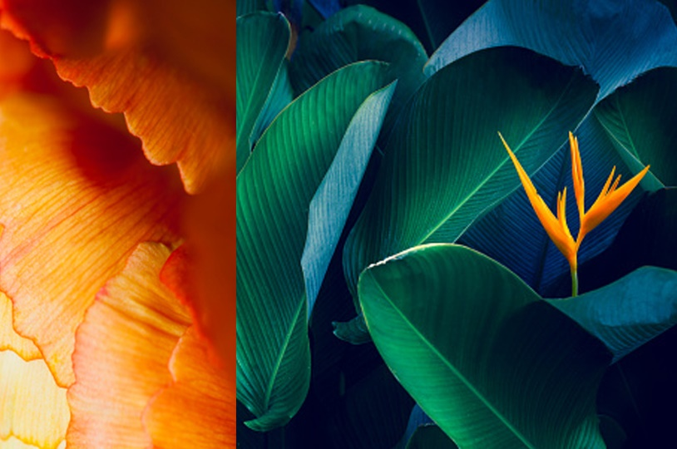

|  |
| --- |
| CS 1103 - FR02B  Assignment 4 |
| By Ngoc Phuong Anh Nguyen - 3712361  March 2021 |

# **Problems:**

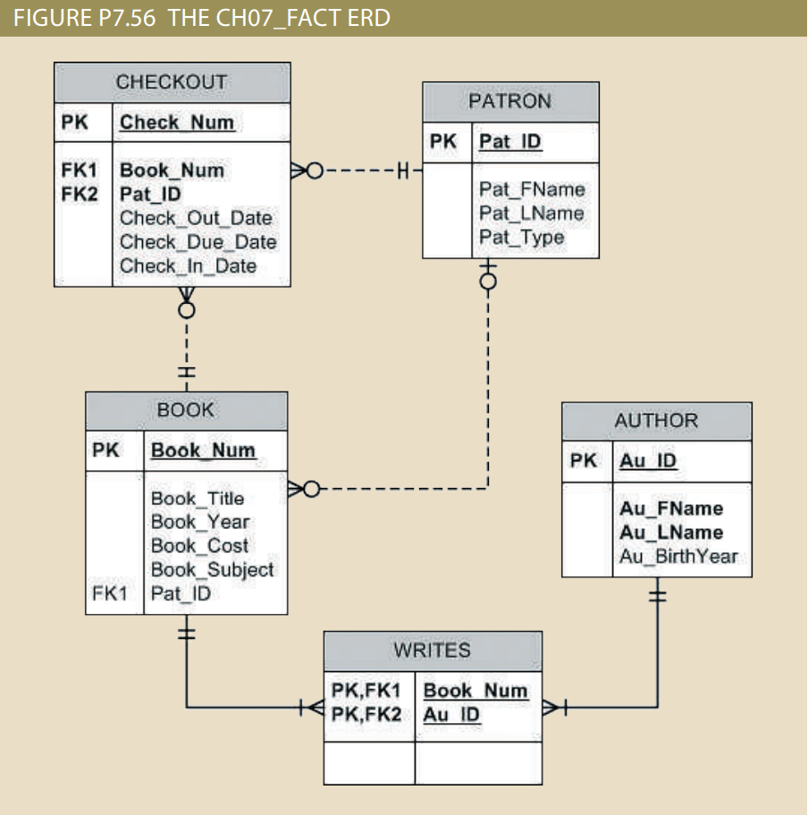

Figure P7.56: The Ch07_Fact ERD

## Problem 60: Write a query to display the different years in which books have been published. Include each year only once and sort the results by year (Figure P7.60).

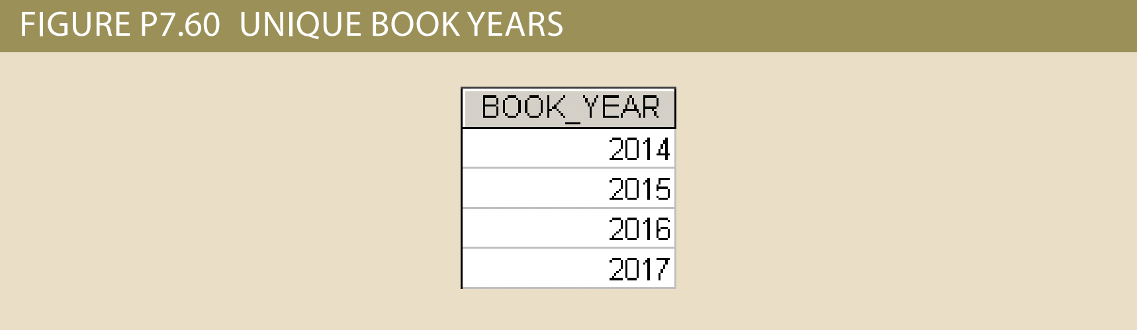

Figure P7.60: Sample output of Query 60

select distinct BOOK_YEAR from BOOK order by BOOK_YEAR asc;

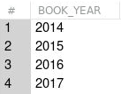

Figure : Output result of Query 60

## Problem 61: Write a query to display the different subjects on which FACT has books. Include each subject only once and sort the results by subject (Figure P7.61).

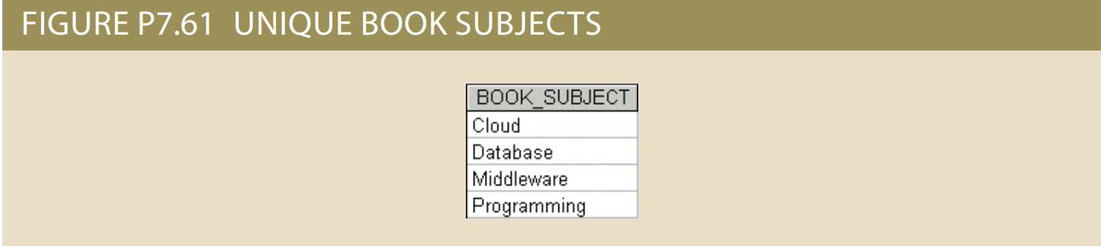

Figure P7.61: Sample output of Query 61

select distinct BOOK_SUBJECT from BOOK order by BOOK_SUBJECT asc;

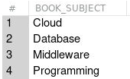

Figure : Output result of Query 61

## Problem 65: Write a query to display the book number, title, and cost for all books that cost $59.95 sorted by book number (Figure P7.65).

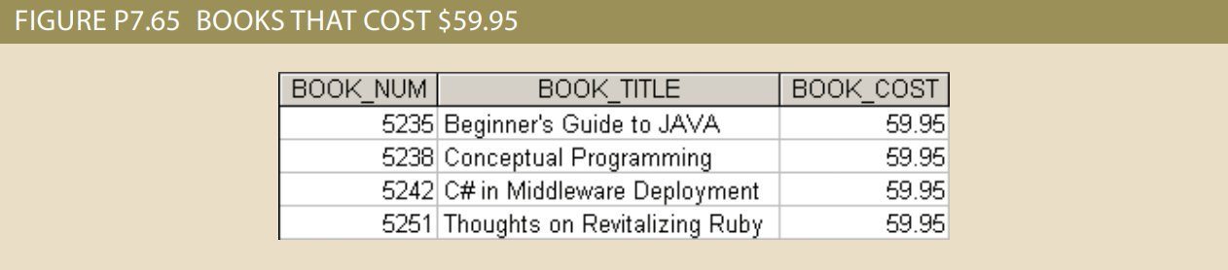

Figure P7.65: Sample output of Query 65

select BOOK_NUM, BOOK_TITLE, BOOK_COST from BOOK where BOOK_COST = 59.95 order by BOOK_NUM asc;

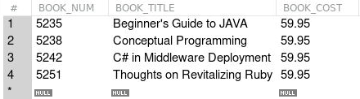

Figure : Output result of Query 65

## Problem 72: Write a query to display the patron ID, first and last name of all patrons who are students, sorted by patron ID (Figure P7.72). (44 rows)

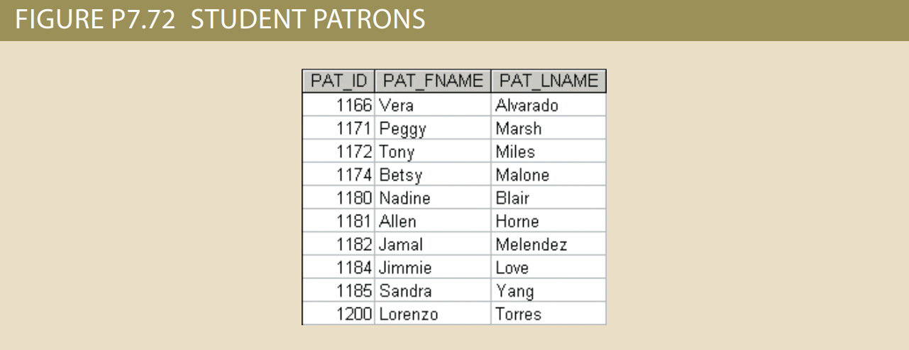

Figure P7.72: Sample output of Query 72

select PAT_ID, PAT_FNAME, PAT_LNAME from PATRON where PAT_TYPE = "student" order by PAT_ID asc;

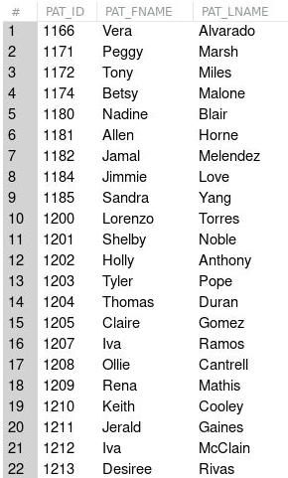

Figure : Output result of Query 72 (Part 1)

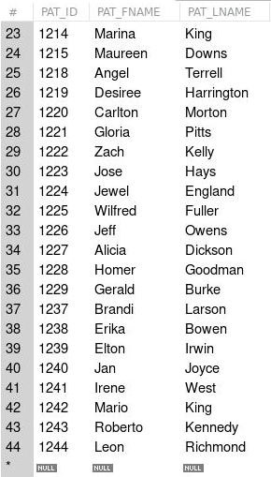

Figure : Output result of Query 72 (Part 2)

## Problem 73: Write a query to display the patron ID, first and last name, and patron type for all patrons whose last name begins with the letter “C,” sorted by patron ID (Figure P7.73).

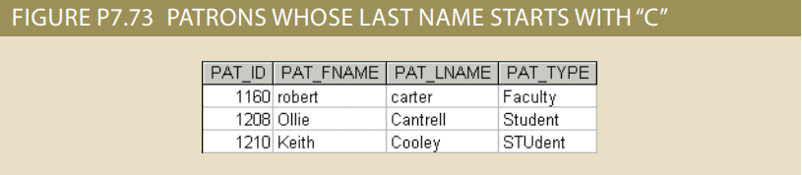

Figure P7.73: Sample output of Query 73

select PAT_ID, PAT_FNAME, PAT_LNAME, PAT_TYPE from PATRON where substring(PAT_LNAME,1,1) = "c" order by PAT_ID asc;

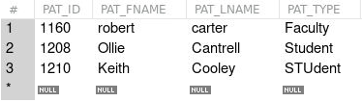

Figure : Output result of Query 73

## Problem 74: Write a query to display the author ID, first and last name of all authors whose year of birth is unknown. Sort the results by author ID (Figure P7.74).

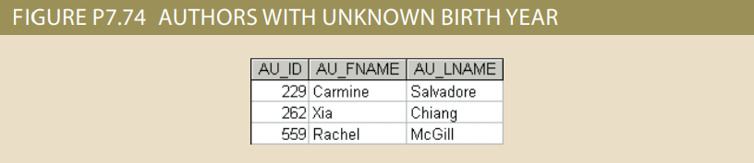

Figure P7.74: Sample output of Query 74

select AU_ID, AU_FNAME, AU_LNAME from AUTHOR where AU_BIRTHYEAR is null order by AU_ID asc;

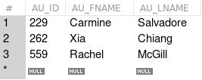

Figure : Output result of Query 74

## Problem 78: Write a query to display the number of books in the FACT system (Figure P7.78).

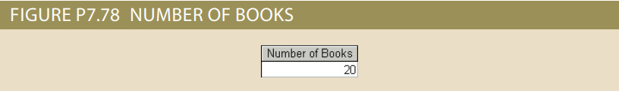

Figure P7.78: Sample output of Query 78

select count(BOOK_NUM) as "Number of Books" from BOOK;



Figure : Output result of Query 78

## Problem 79: Write a query to display the number of different book subjects in the FACT system (Figure P7.79).

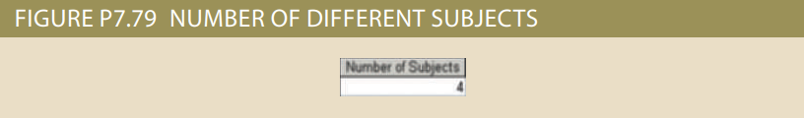

Figure P7.79: Sample output of Query 79

select count(distinct(BOOK_SUBJECT)) as "Number of Subjects" from BOOK;



Figure : Output result of Query 79

## Problem 80: Write a query to display the number of books that are available (not currently checked out) (Figure P7.80).

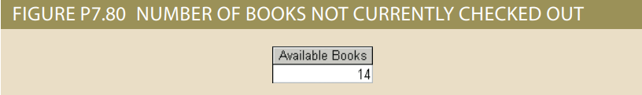

Figure P7.80: Sample output of Query 80

select count(BOOK_NUM) as "Available Books" from BOOK where PAT_ID is null;



Figure : Output result of Query 80

## Problem 81: Write a query to display the highest book cost in the system (Figure P7.81)

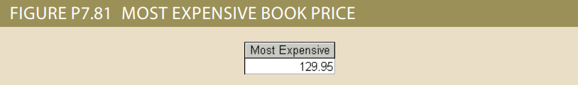

Figure P7.81: Sample output of Query 81

select max(BOOK_COST) as "Most Expensive" from BOOK;



Figure : Output result of Query 81

## Problem 82: Write a query to display the lowest book cost in the system (Figure P7.82).

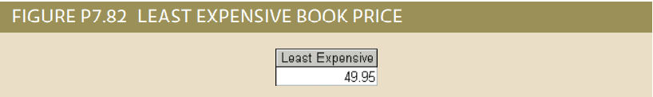

Figure P7.82: Sample output of Query 82

select min(BOOK_COST) as "Least Expensive" from BOOK;



Figure : Output result of Query 82

## Problem 83: Write a query to display the number of different patrons who have ever checked out a book (Figure P7.83).

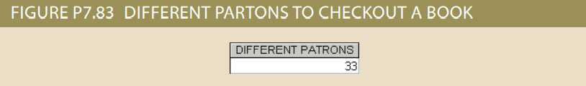

Figure P7.83: Sample output of Query 83

select count(distinct(PAT_ID)) as "DIFFERENT PATRONS" from CHECKOUT;



Figure : Output result of Query 83

## Problem 85: Write a query to display the author ID and the number of books written by that author. Sort the results in descending order by number of books, then in ascending order by author ID (Figure P7.85).

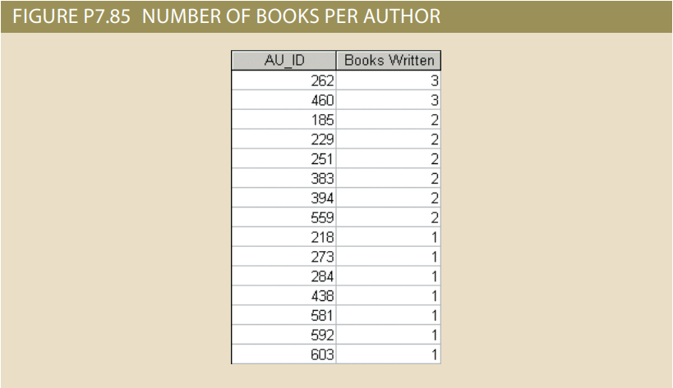

Figure P7.85: Sample output of Query 85

select distinct(AU_ID), count(BOOK_NUM) as "Books Written" FROM WRITES group by AU_ID order by count(BOOK_NUM) desc, AU_ID asc;

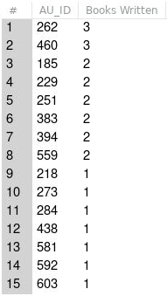

Figure : Output result of Query 85

## Problem 101: Write a query to display the patron ID, first and last name of all patrons who have never checked out any book. Sort the result by patron last name and then first name (Figure P7.101).

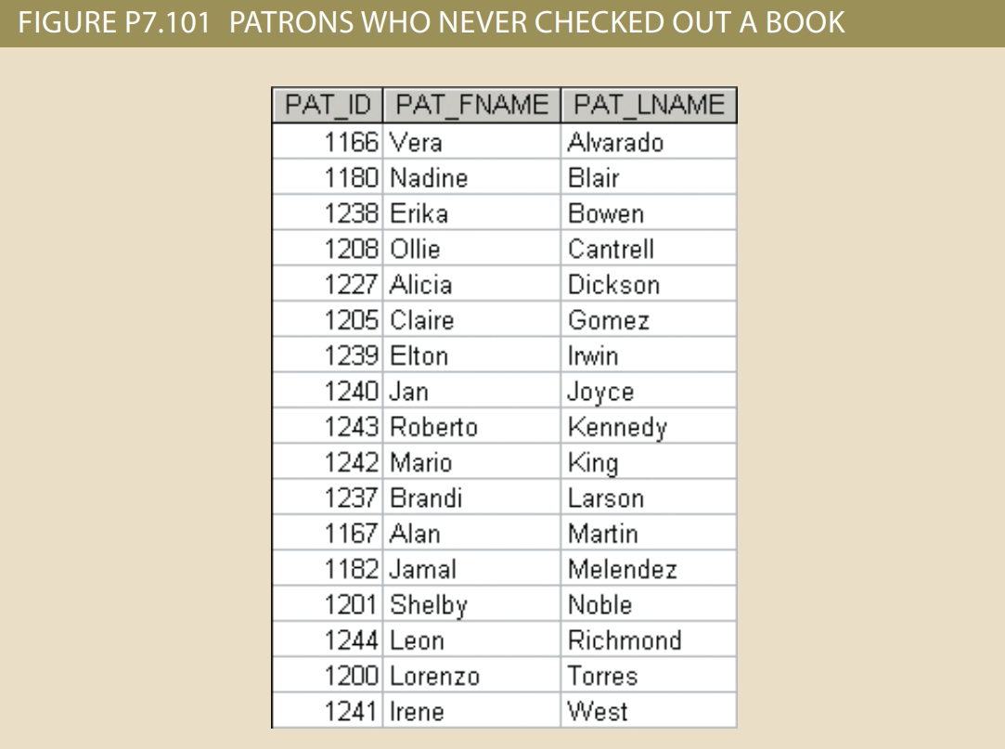

Figure P7.101: Sample output of Query 101

select PAT_ID, PAT_FNAME, PAT_LNAME from PATRON where PAT_ID not in

(SELECT PAT_ID FROM CHECKOUT)

order by PAT_LNAME, PAT_FNAME;

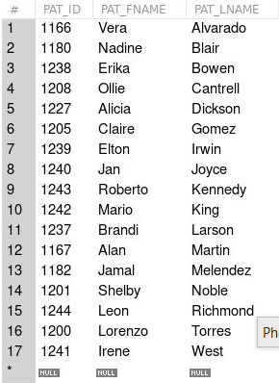

Figure : Output result of Query 101